|  |
| --- |
| Bayer Healthcare |
| Doc41 Web UI User Guide |
|  |
|  |
| **Ingo Kaulbach (Bayer Business Services GmbH)** |
| **12.11.2013** |

|  |
| --- |
|  |

|  |  |
| --- | --- |
| Infobox |  |
| Applicable System: | External Access: Doc41 Web UI |
| Title: | User Guide |
| Author: | Ingo Kaulbach (EVFPU) |
| Change history (version number, last change, changed by, date) | 1. Ingo Kaulbach EVFPU, 2013-11-12, initial setup   1.1 Ingo Kaulbach EVFPU, 2014-01-15, infobox added |
| Current Version of document: | 1.1 |
|  |  |

Content

Login 4

Login screen 4

My Profile 5

Upload 6

Download 7

Roles 8

Carrier 8

Download: Air waybill 8

Download: Bill of Lading 8

Download: Shippers declaration 9

Download: Waybill 10

Download: FDA certificate 11

Download: CMR (outgoing) 12

Upload: CMR (incoming) 13

Upload: Air waybill 14

Upload: Bill of Lading 15

Customs Broker 16

DirectDownload: Air waybill 16

DirectDownload: Bill of Lading 16

DirectDownload: Shippers declaration 16

DirectDownload: Waybill 16

DirectDownload: FDA certificate 16

Material Supplier 17

Upload: Supplier CoA 17

Product Supplier 18

Upload: Delivery Certificate 18

ViewerCountry 19

Download: Delivery Certificate 19

ViewerCustomer 20

Download: Delivery Certificate 20

Layout Supplier 21

Download: HighRes Layout 21

Download: LowRes Artwork 22

Upload: HighRes Layout 23

PM supplier 24

Download: Packaging specification 24

Download: Technical drawing 24

Download: Technical packaging and Delivery requirements 25

Download: CMR (outgoing) 26

# Login

## Login screen

Open   
<https://doc41.bayer.com/>   
in your browser and enter your user id and password if you are already registered.

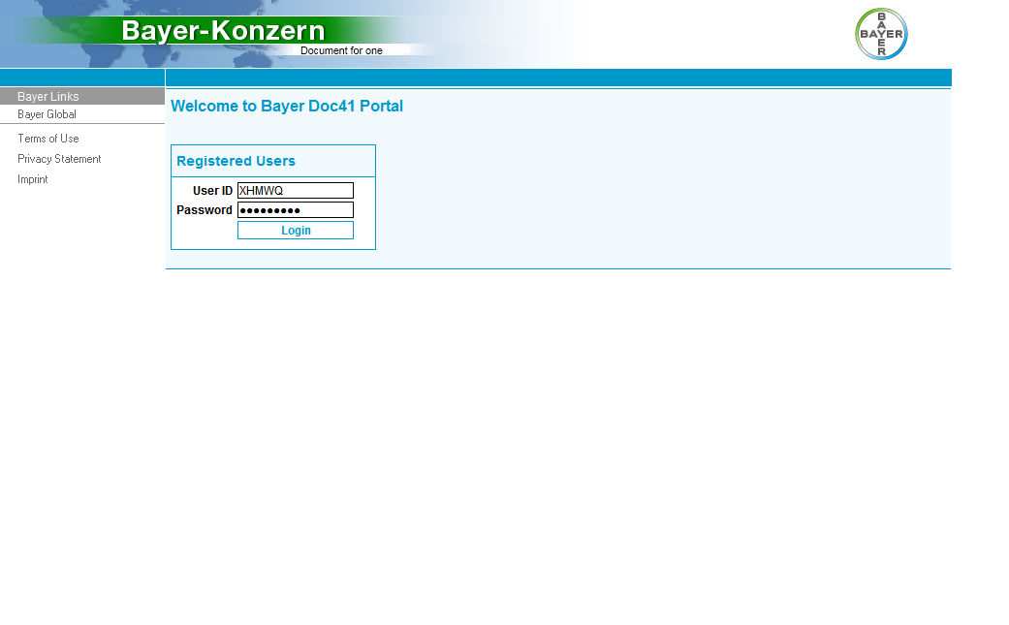

# My Profile

After you have successfully logged in, you will see the “My Profile”-page, where you can find all details of your profile.

You can see your personal details, like first- and surename, cwid, email-address and language.

You can see the roles assigned to your account.

You can also see the partner numbers, countries and plants assigned to your account.

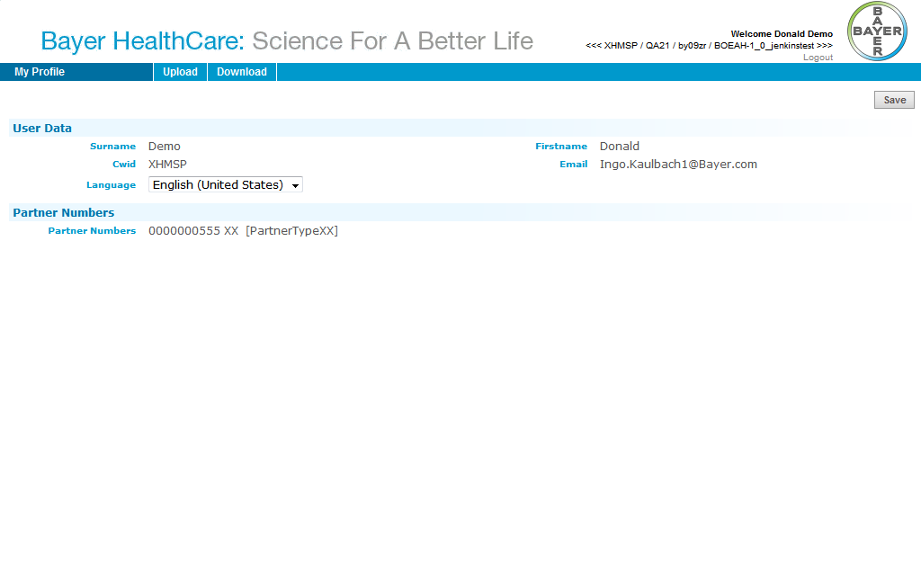

# Upload

If you have a role that allows you to upload a document you will find the Upload-tab in your top navigation menu.

Depending on your roles you will find the types of documents you can upload, for example *Bill of Lading*.

In section Roles you will find which documents you can upload for a certain role.

# Download

If you have a role that allows you to download a document you will find the Download-tab in your top navigation menu.

Depending on your roles you will find the types of documents you can download, for example *Bill of Lading*.

In section Roles you will find which documents you can download for a certain role.

# Roles

## Carrier

### Download: Air waybill

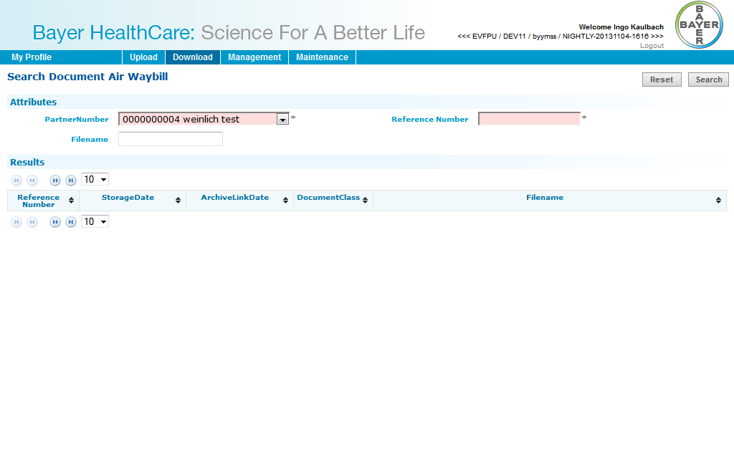

### Download: Bill of Lading

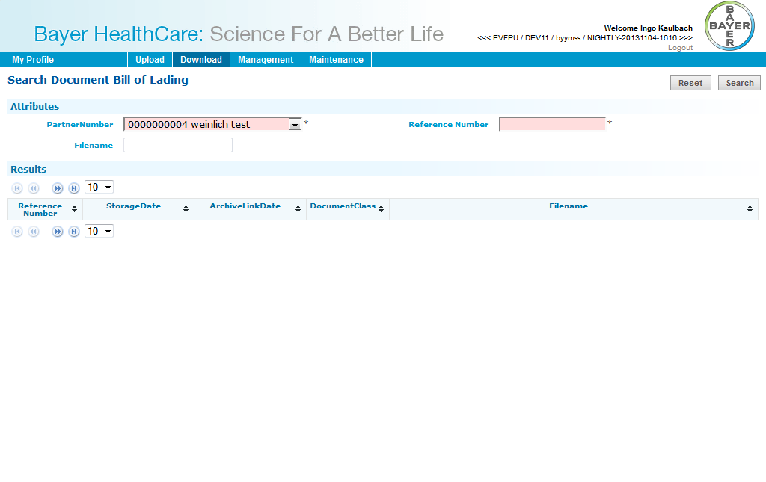

### Download: Shippers declaration

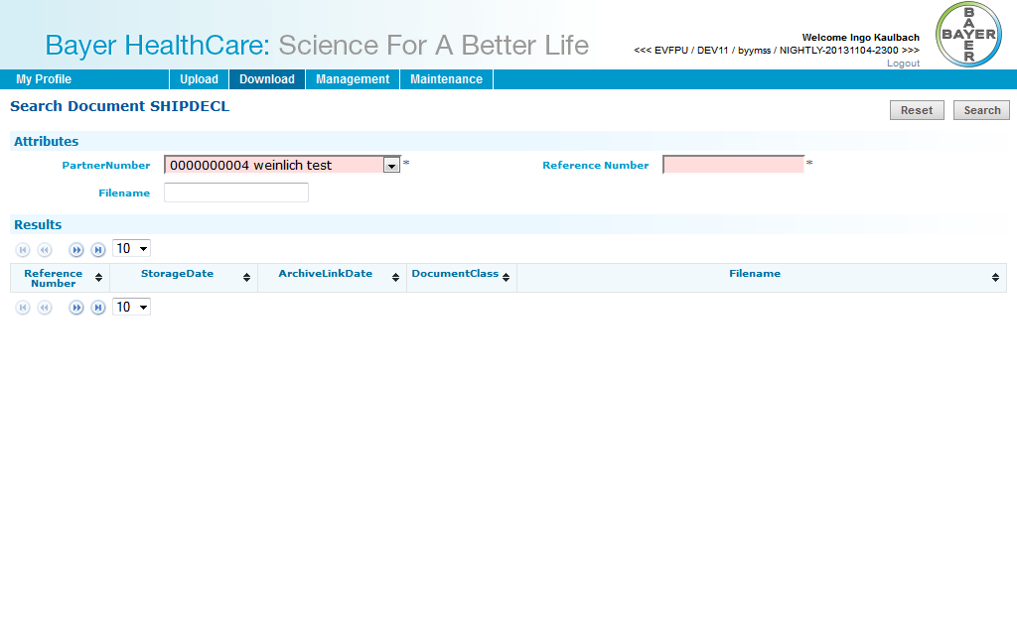

### Download: Waybill

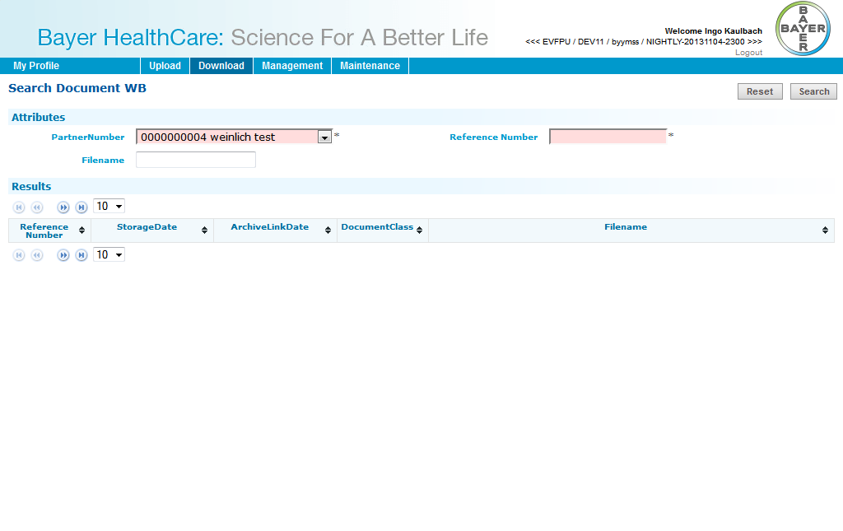

### Download: FDA certificate

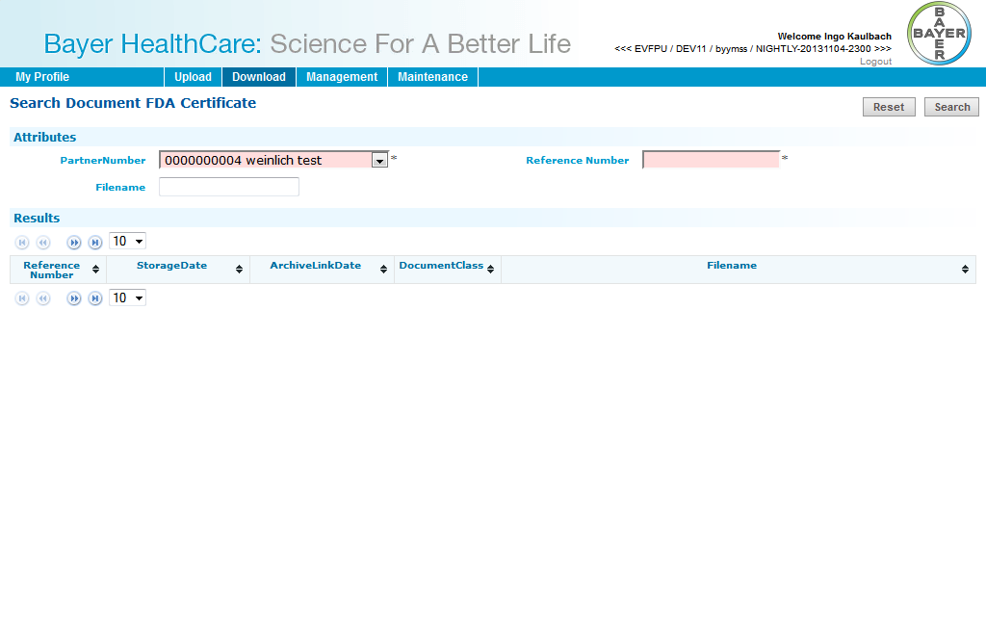

### Download: CMR (outgoing)

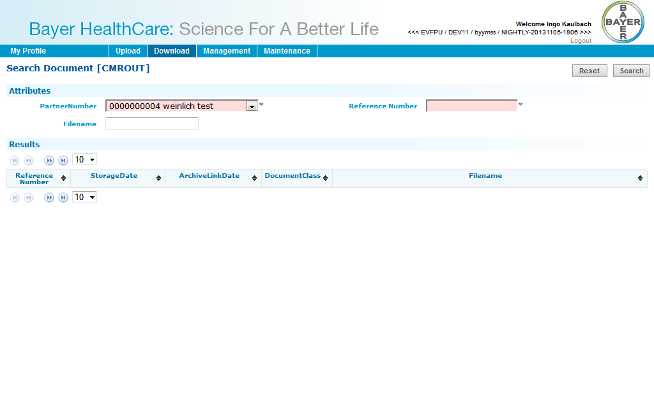

### Upload: CMR (incoming)

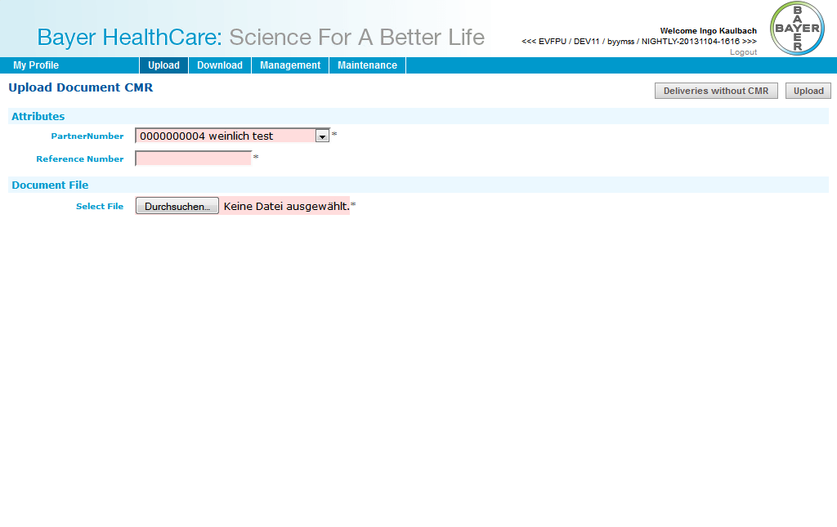

### Upload: Air waybill

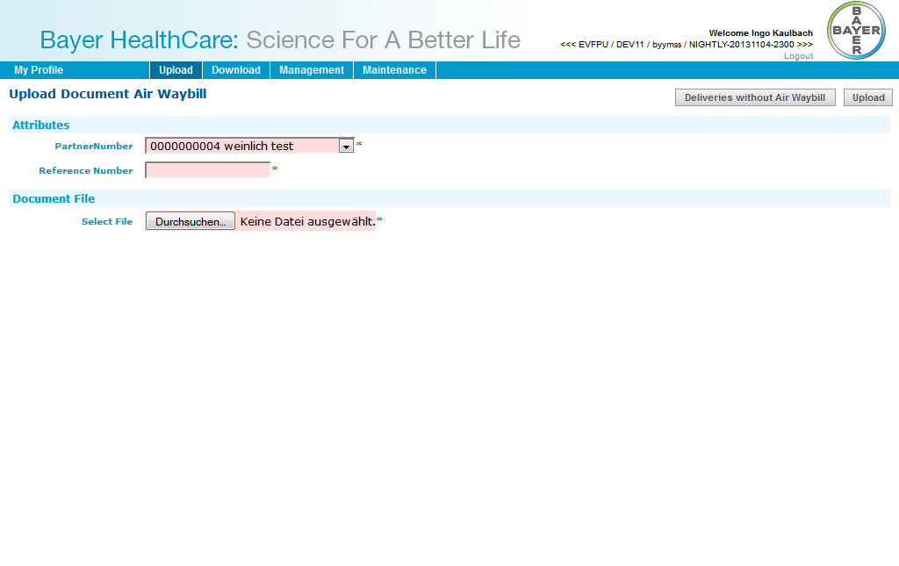

### Upload: Bill of Lading

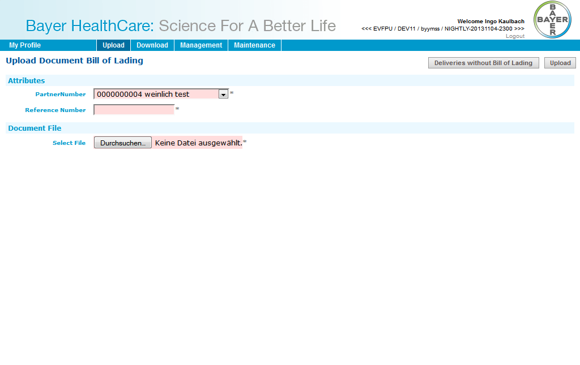

## Customs Broker

### DirectDownload: Air waybill

You will receive a direct link to the document. After clicking on the link you have to login with your username and password. You can download the document directly than.

### DirectDownload: Bill of Lading

You will receive a direct link to the document. After clicking on the link you have to login with your username and password. You can download the document directly than.

### DirectDownload: Shippers declaration

You will receive a direct link to the document. After clicking on the link you have to login with your username and password. You can download the document directly than.

### DirectDownload: Waybill

You will receive a direct link to the document. After clicking on the link you have to login with your username and password. You can download the document directly than.

### DirectDownload: FDA certificate

You will receive a direct link to the document. After clicking on the link you have to login with your username and password. You can download the document directly than.

## Material Supplier

### Upload: Supplier CoA

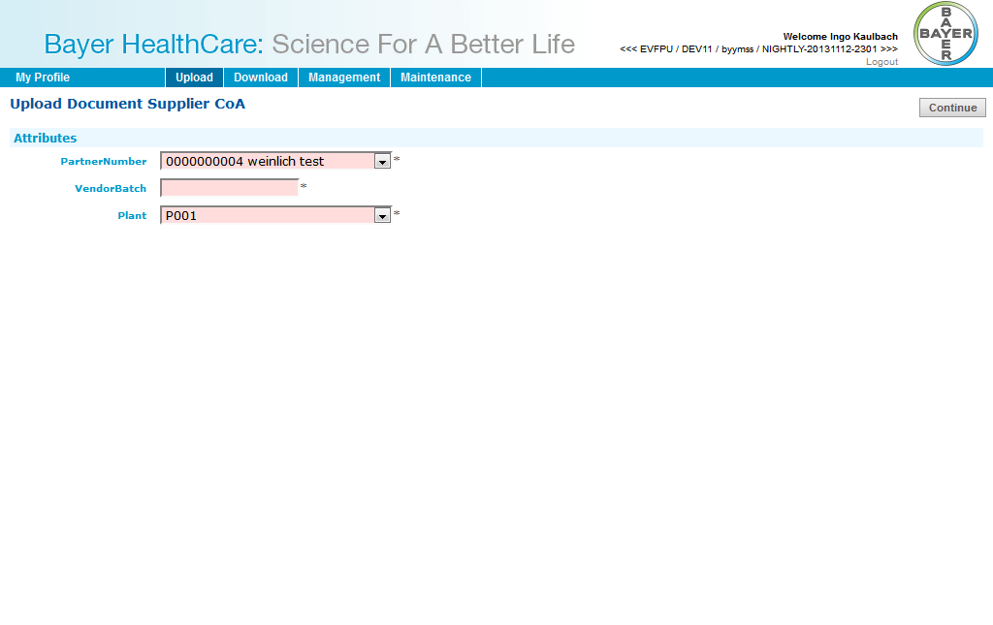

## Product Supplier

### Upload: Delivery Certificate

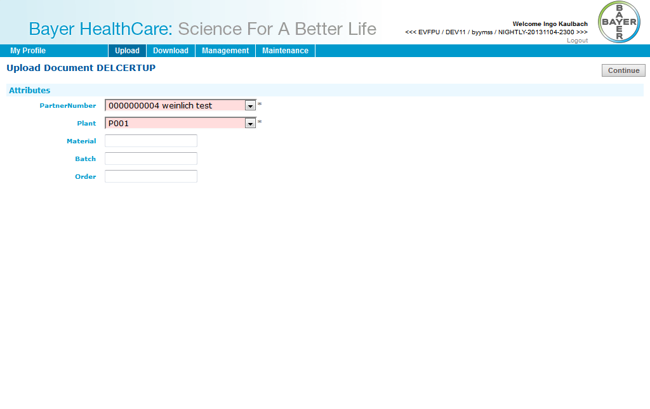

## ViewerCountry

### Download: Delivery Certificate

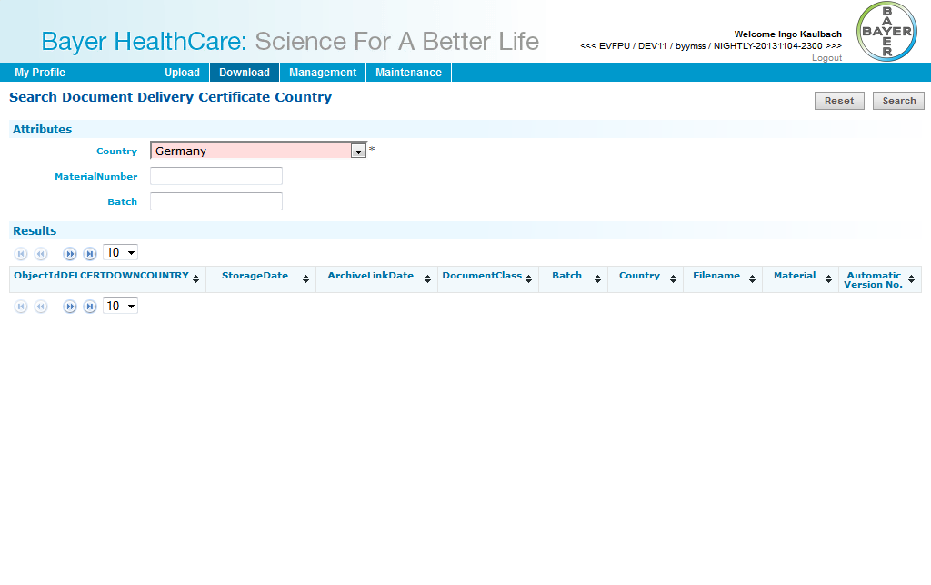

## ViewerCustomer

### Download: Delivery Certificate

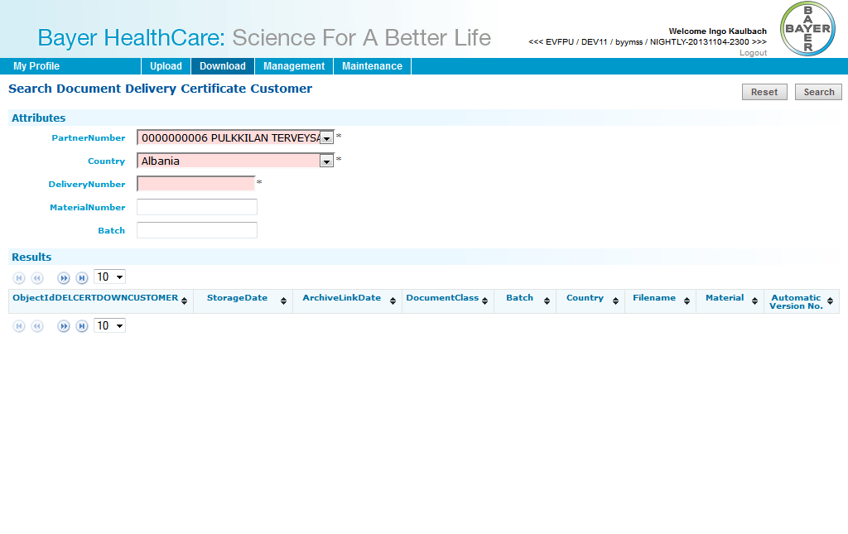

## Layout Supplier

### Download: HighRes Layout

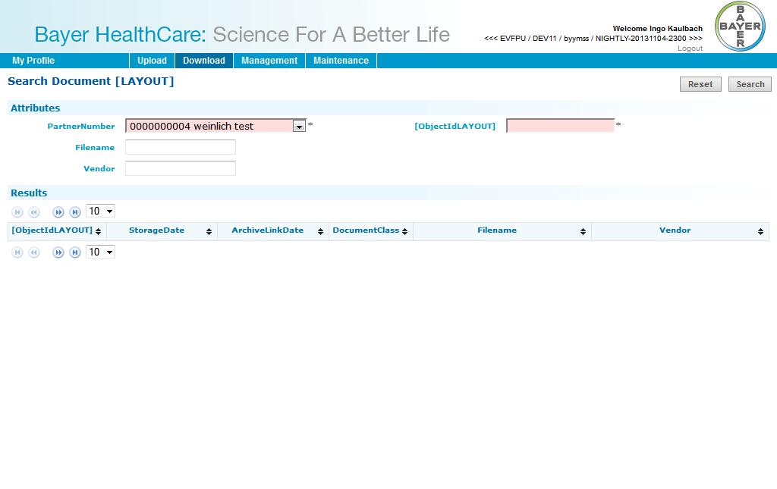

### Download: LowRes Artwork

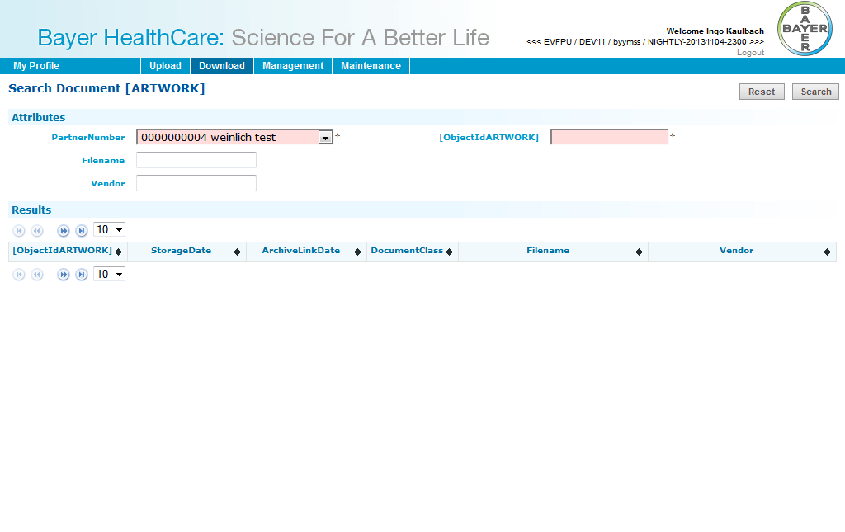

### Upload: HighRes Layout

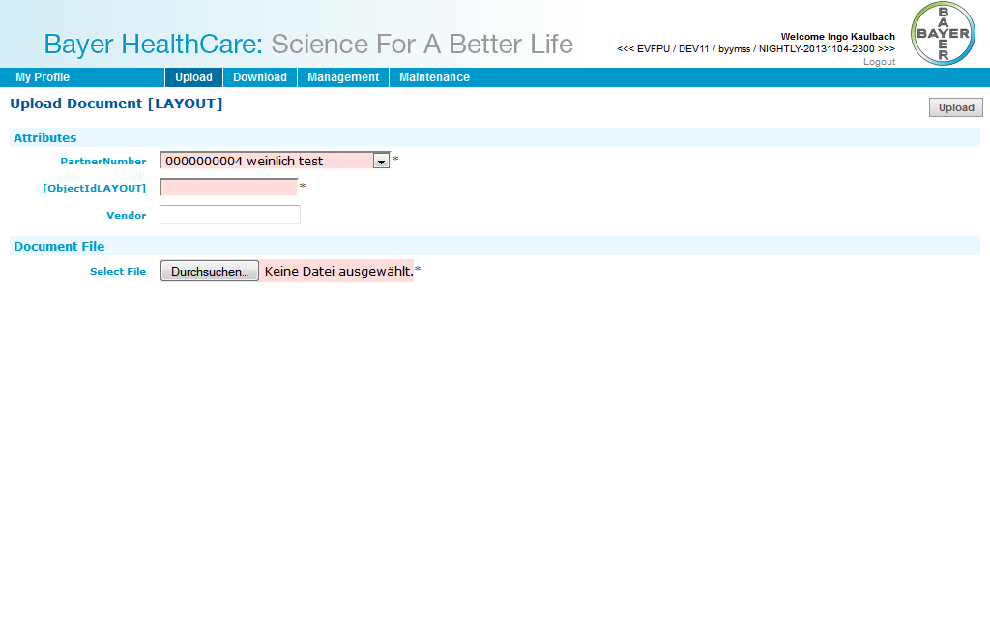

## PM supplier

### Download: Packaging specification

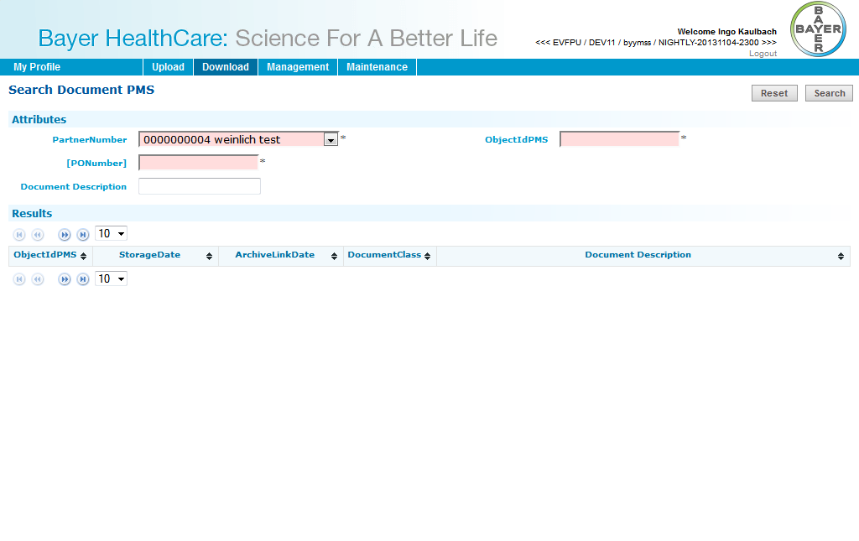

### Download: Technical drawing

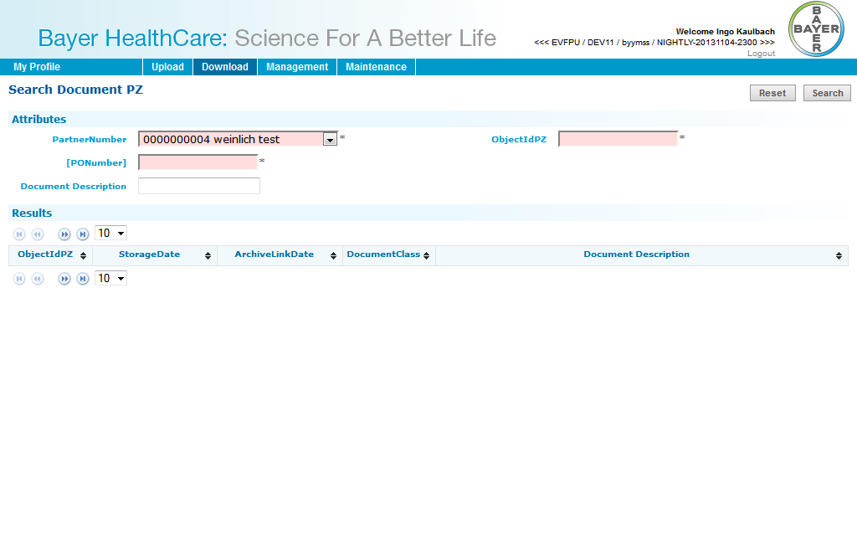

### Download: Technical packaging and Delivery requirements

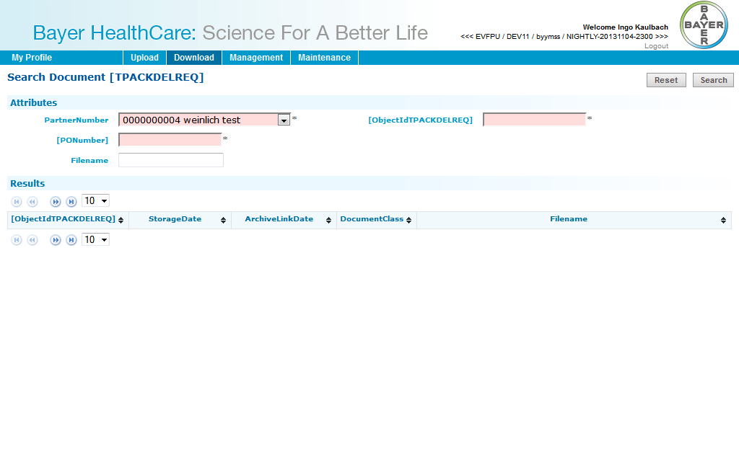

### Download: CMR (outgoing)

